Link Figma: REQ prototype – Figma

UC01: Log in to the system
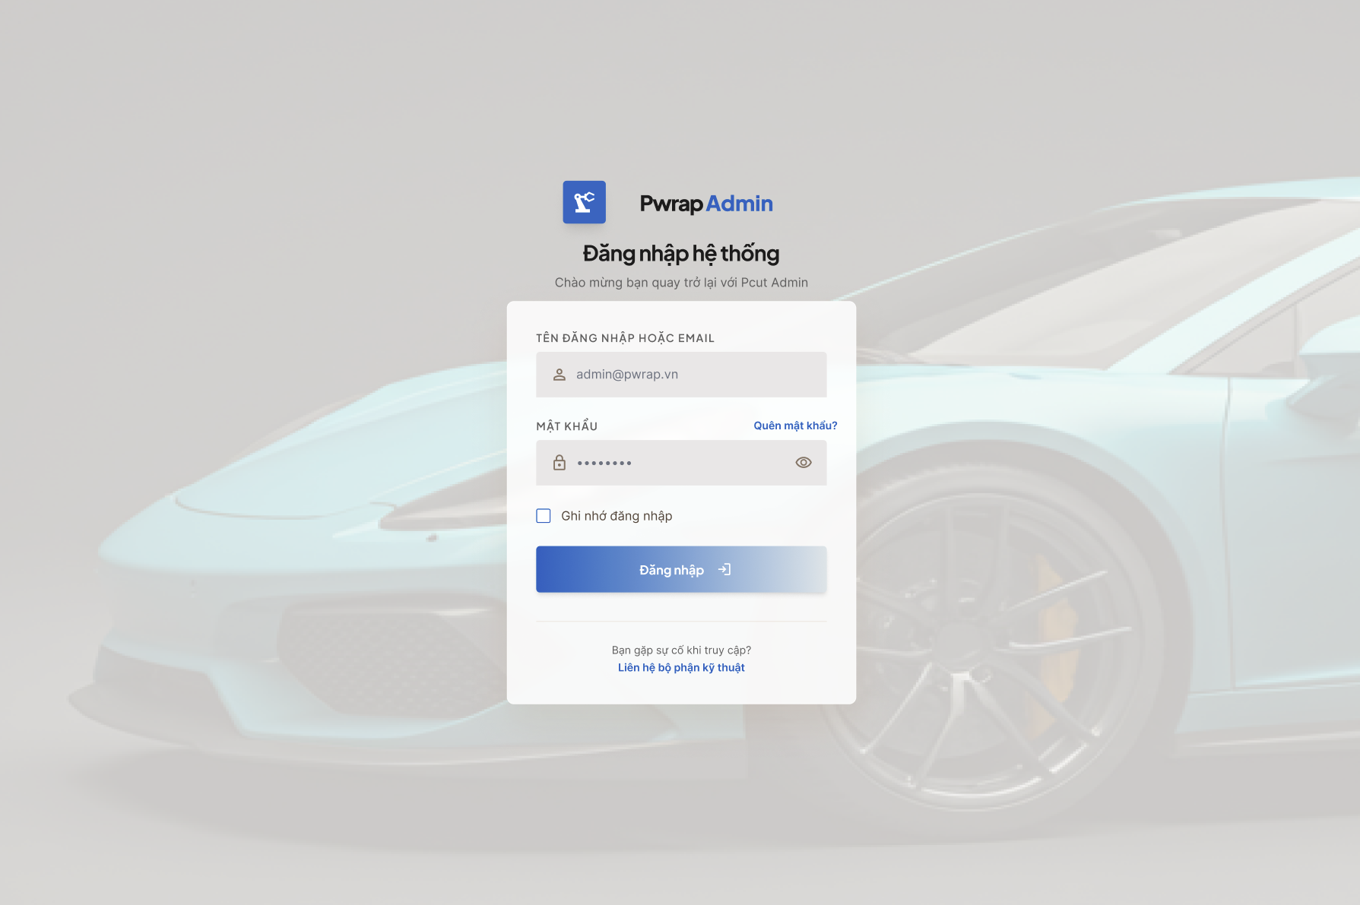
After login, users are redirected to the dashboard.
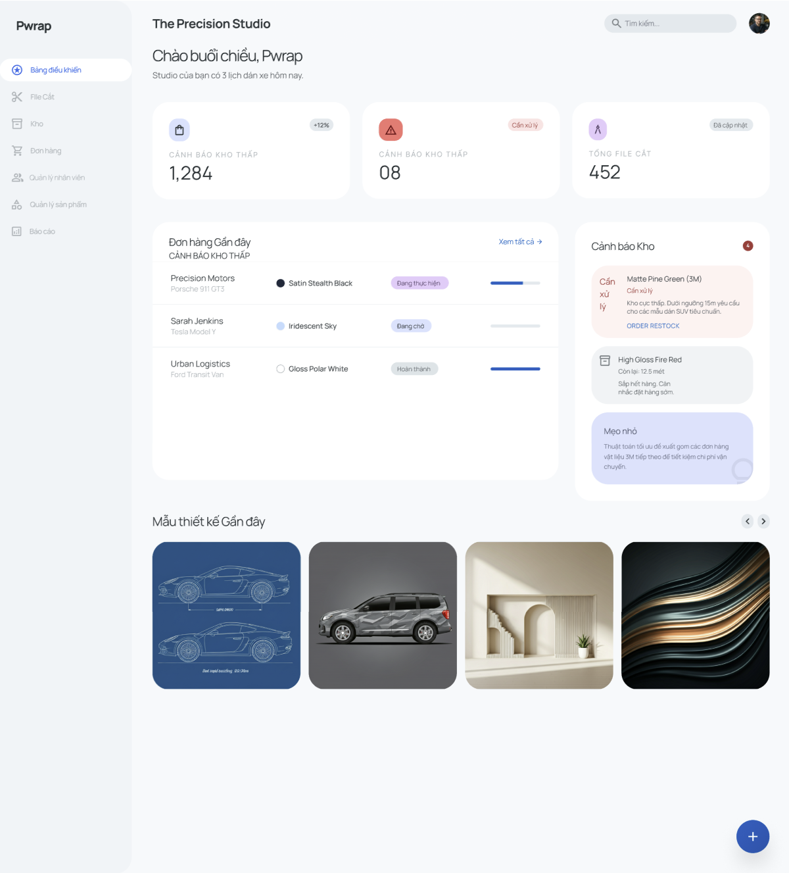
UC02: Manage Staff permissions
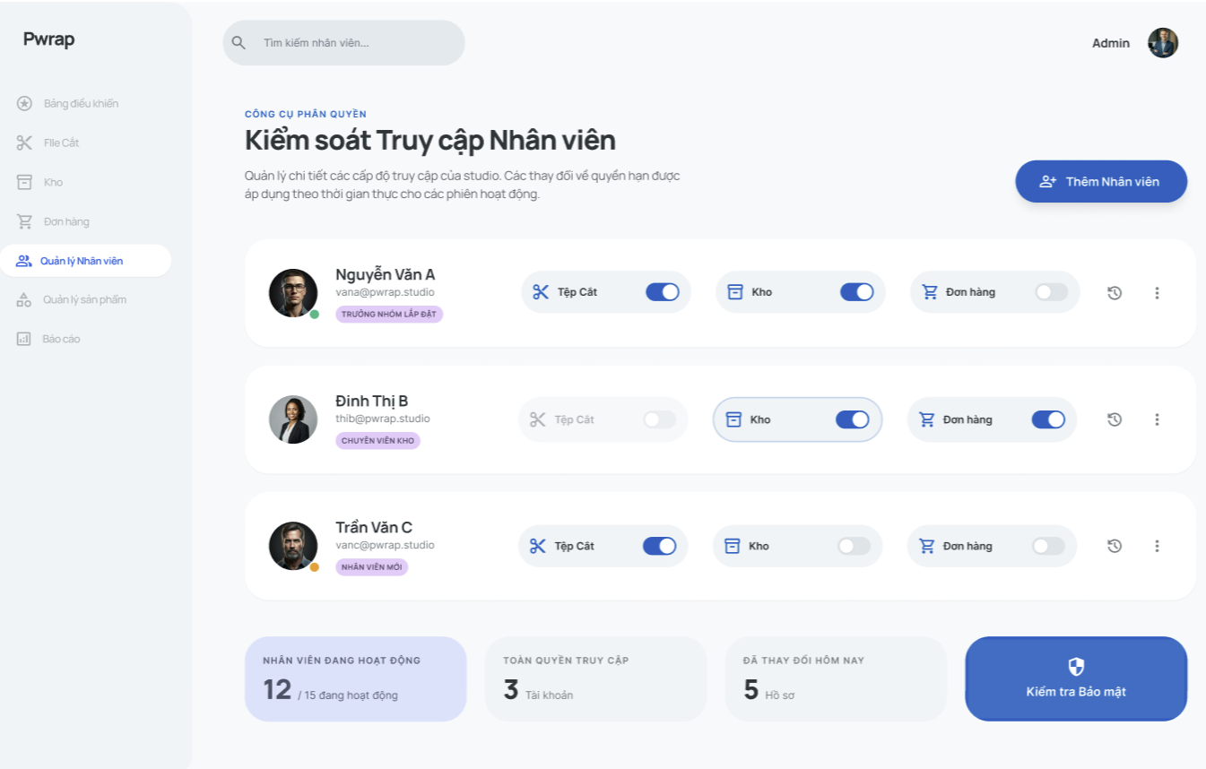
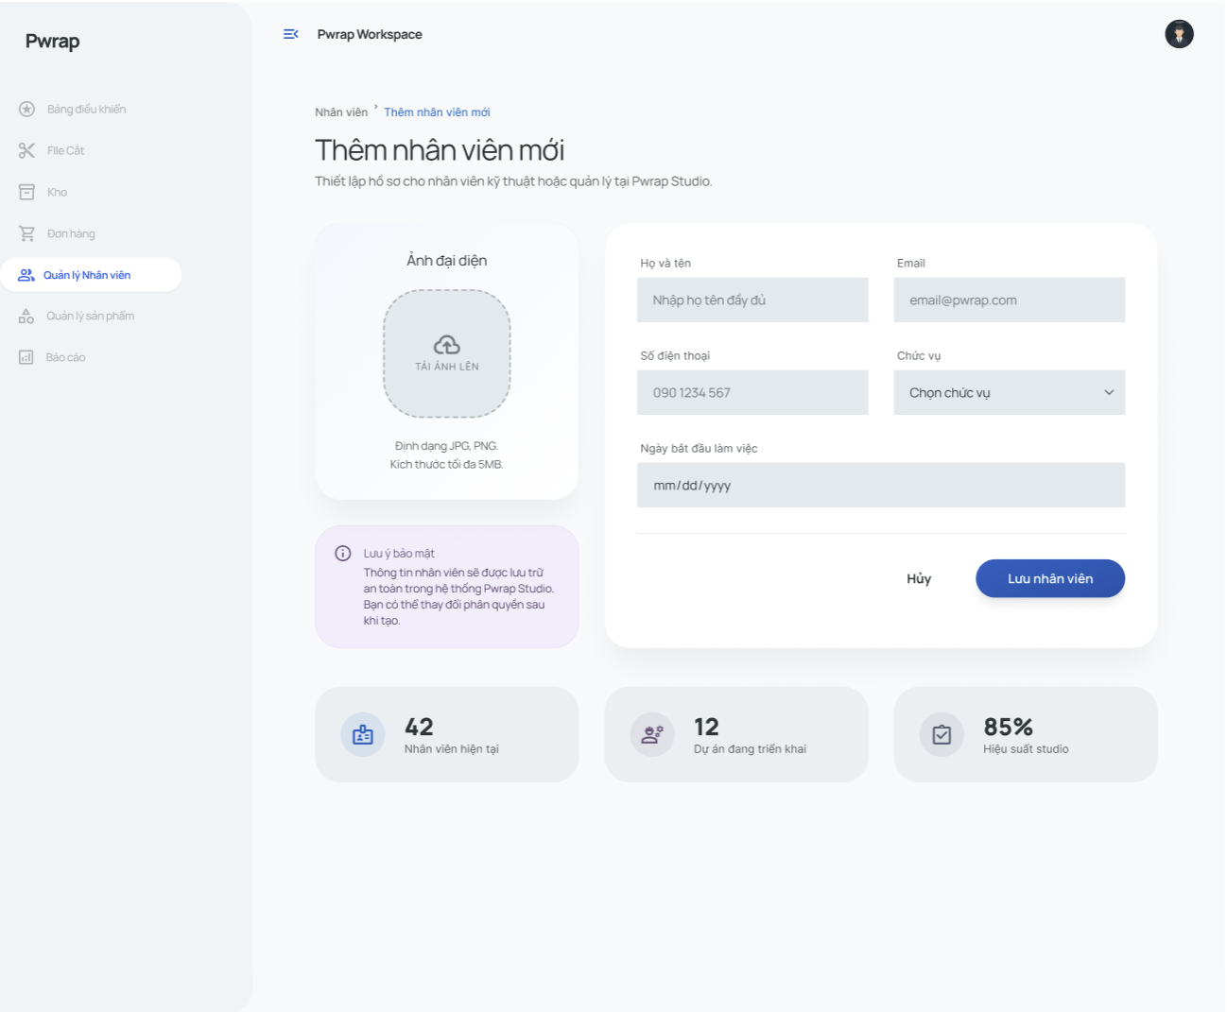
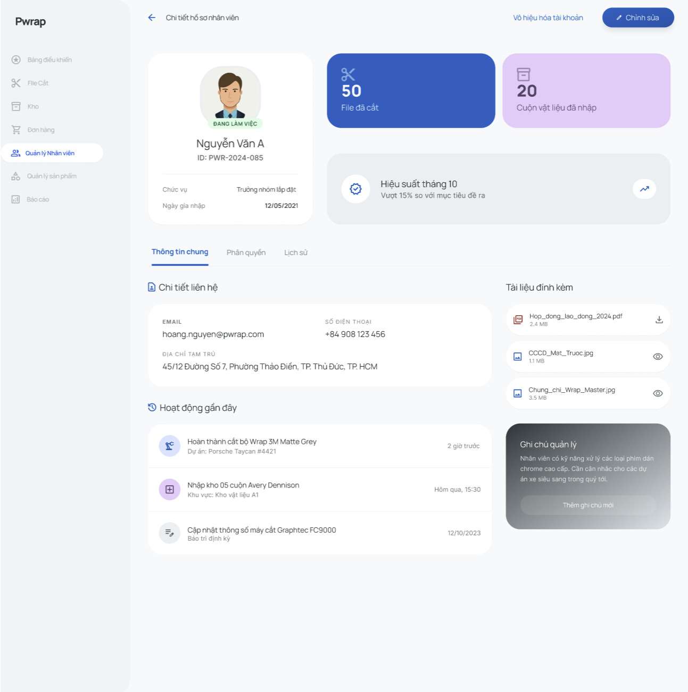
UC03: View system logs

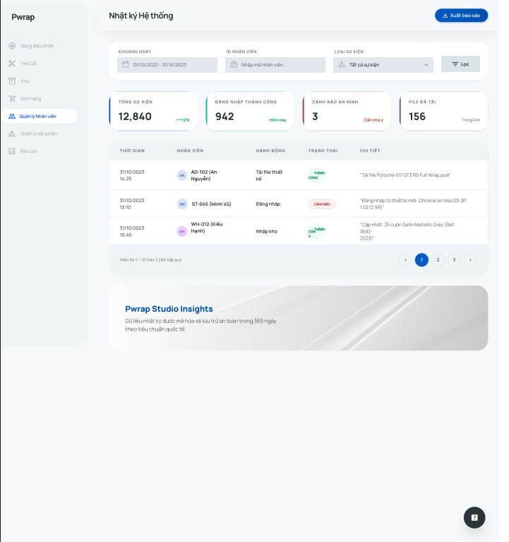
UC04: Upload cut file
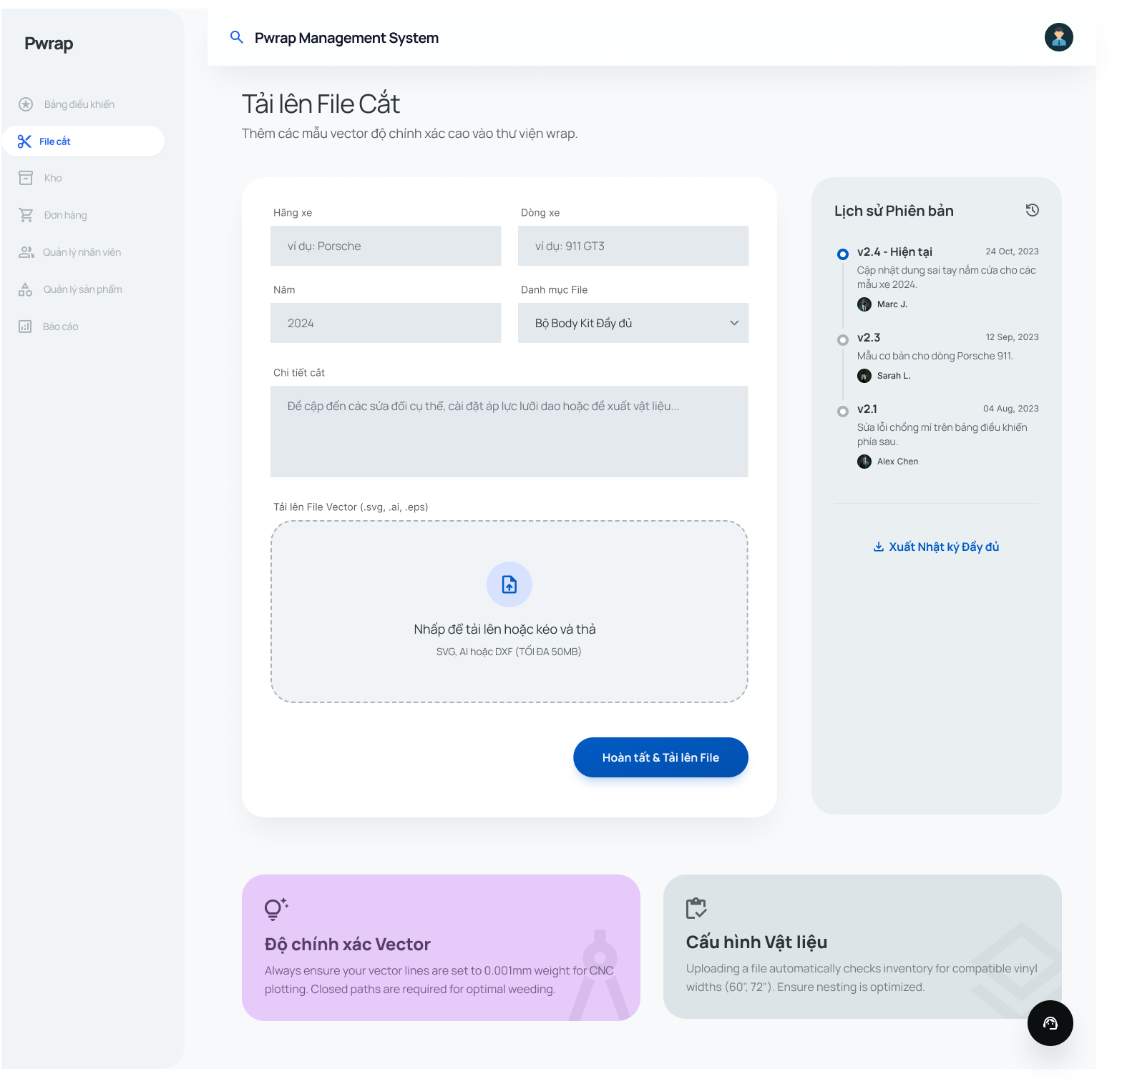
UC05: Search cut file
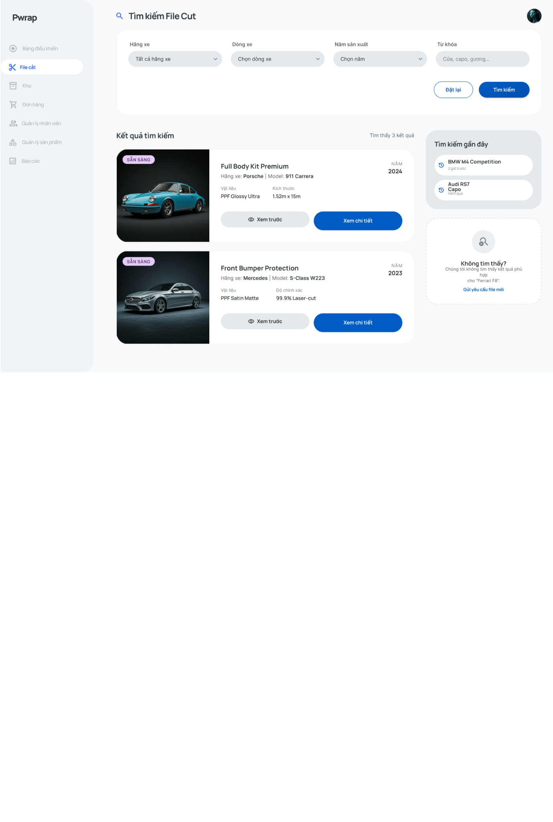
UC06: Restock materials
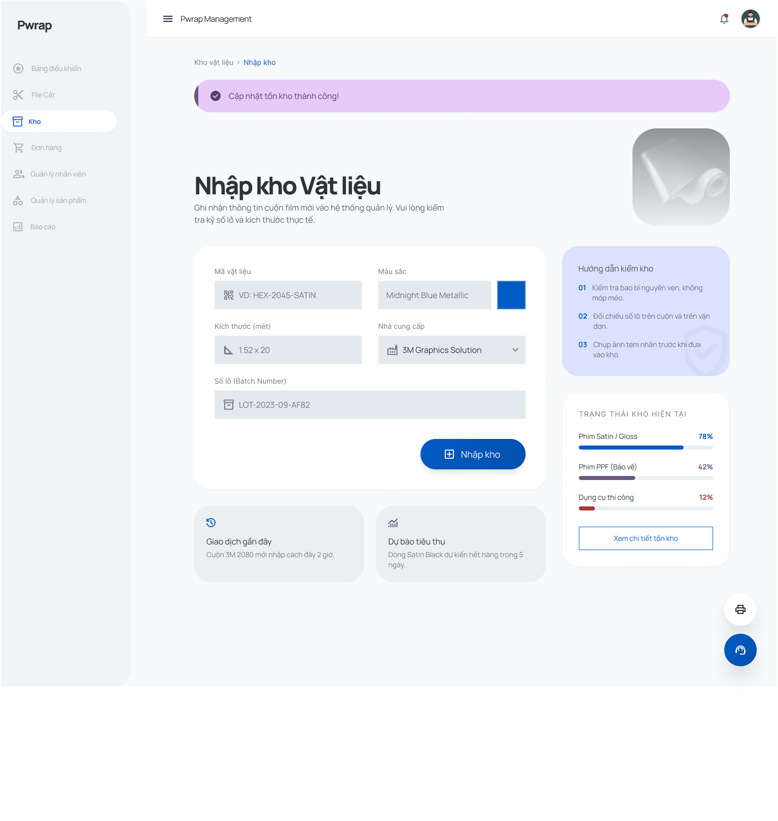
UC07: View inventory
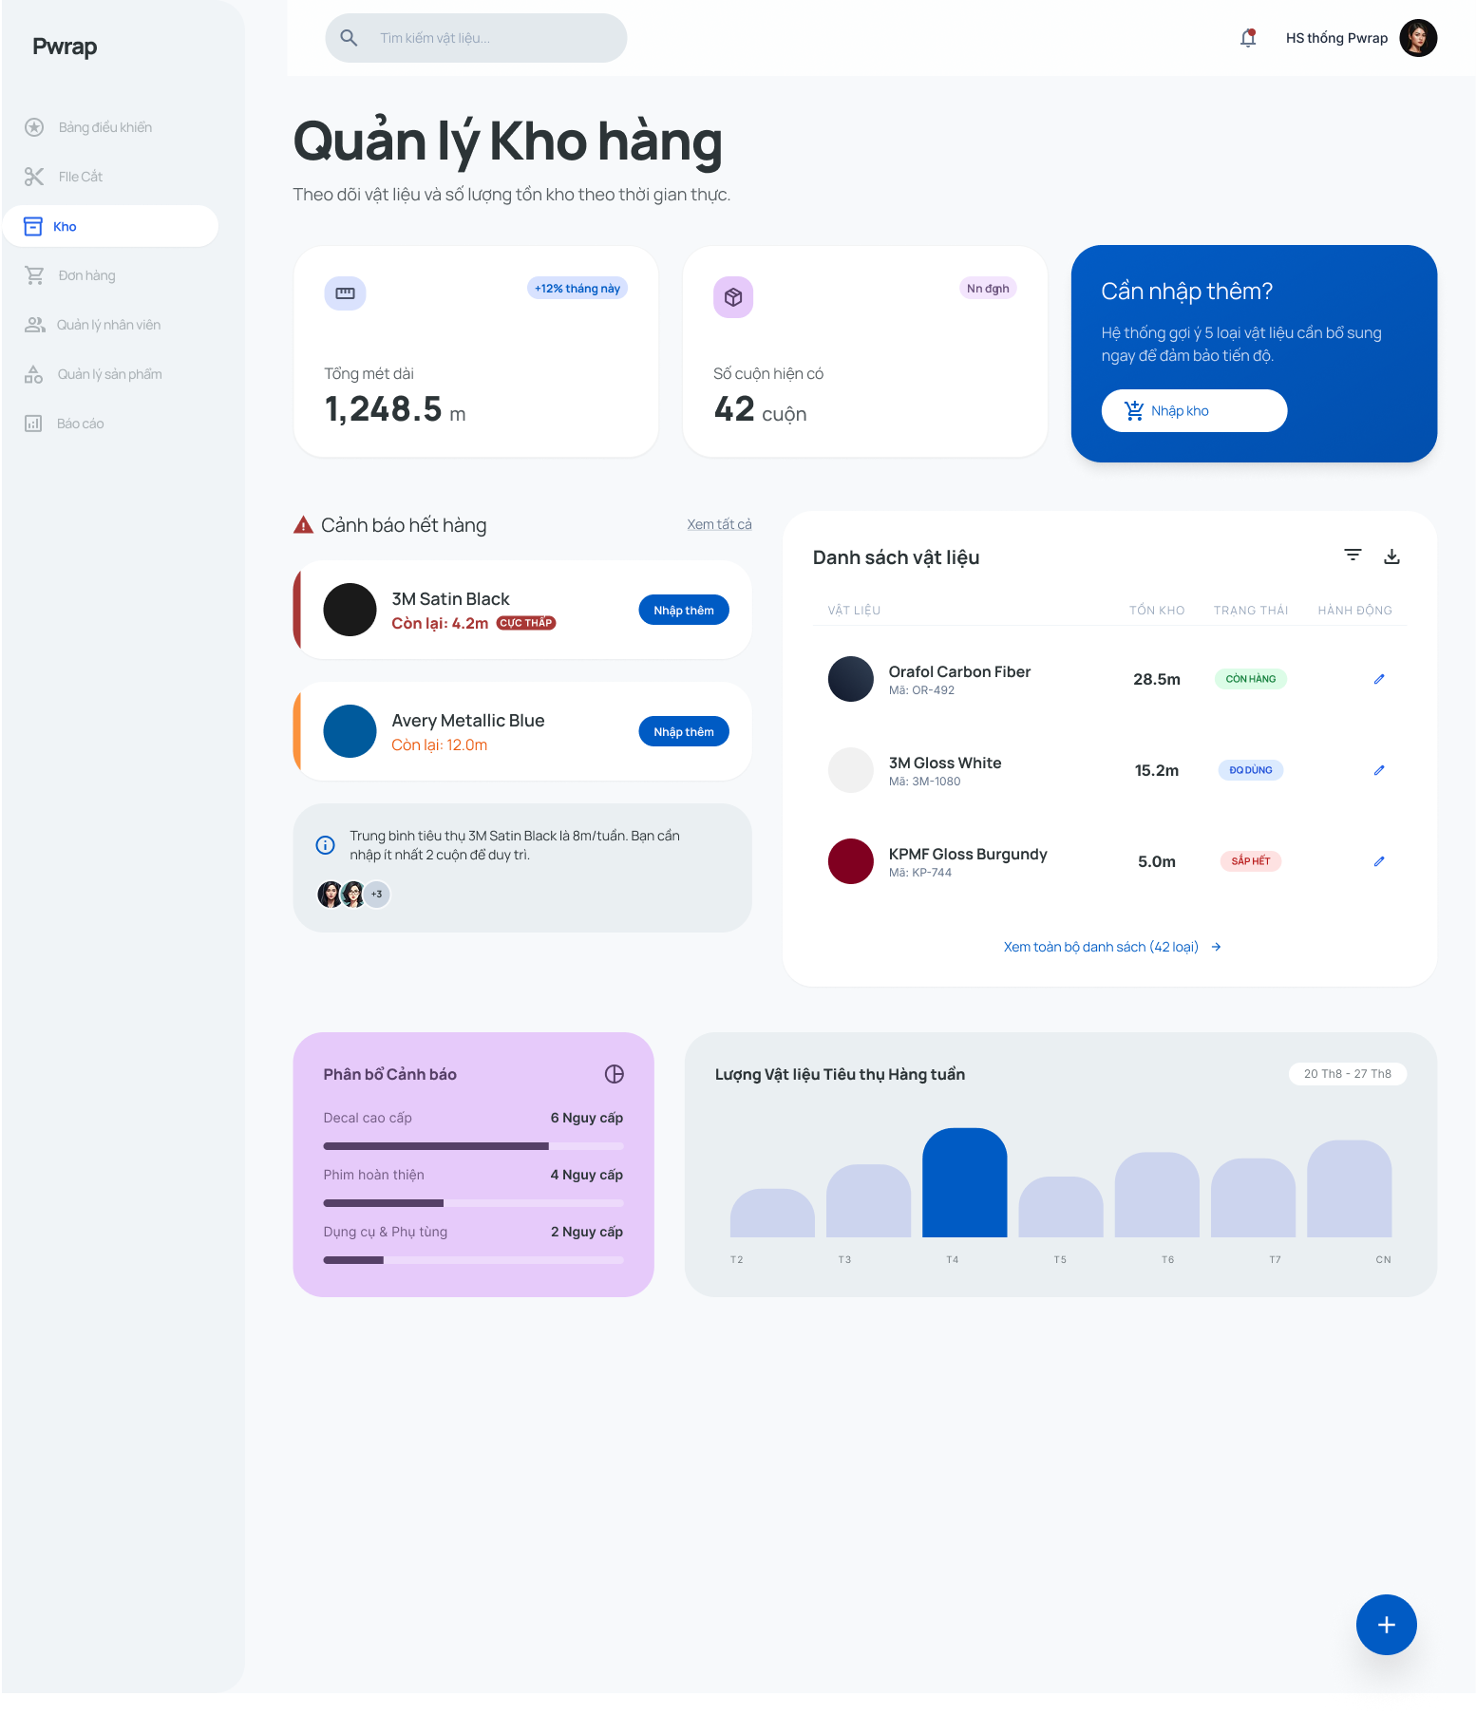
UC08: View inventory alerts
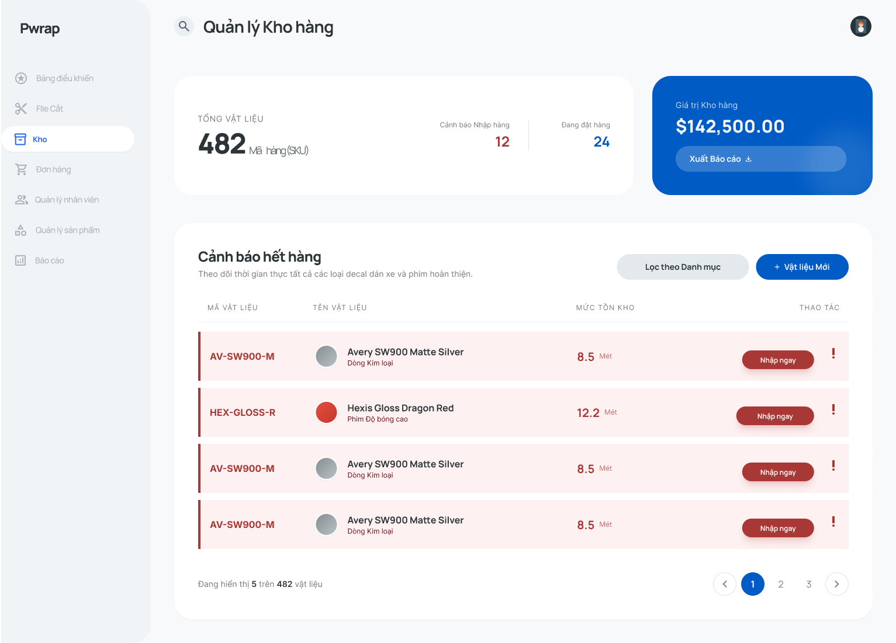
UC09: Create order
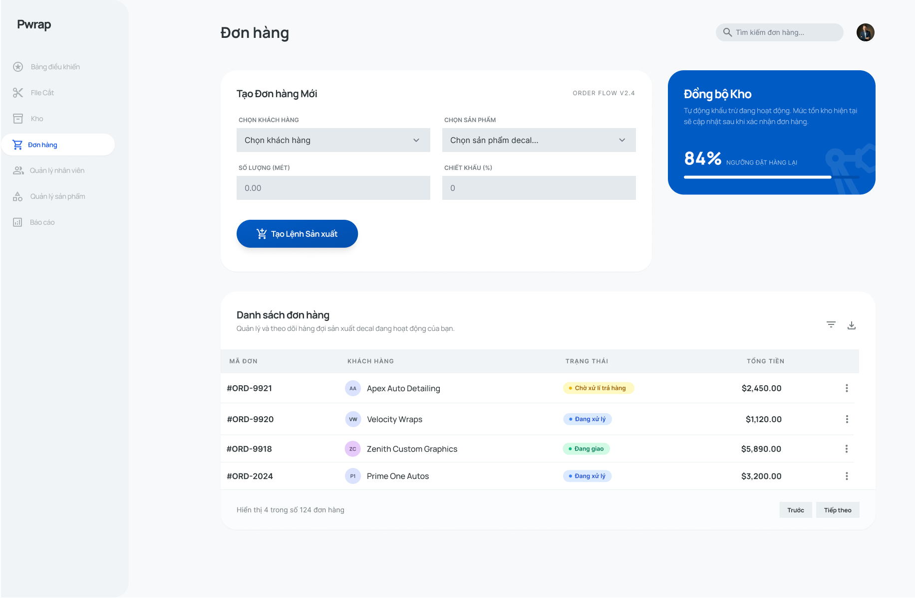
UC10: Update cut file version
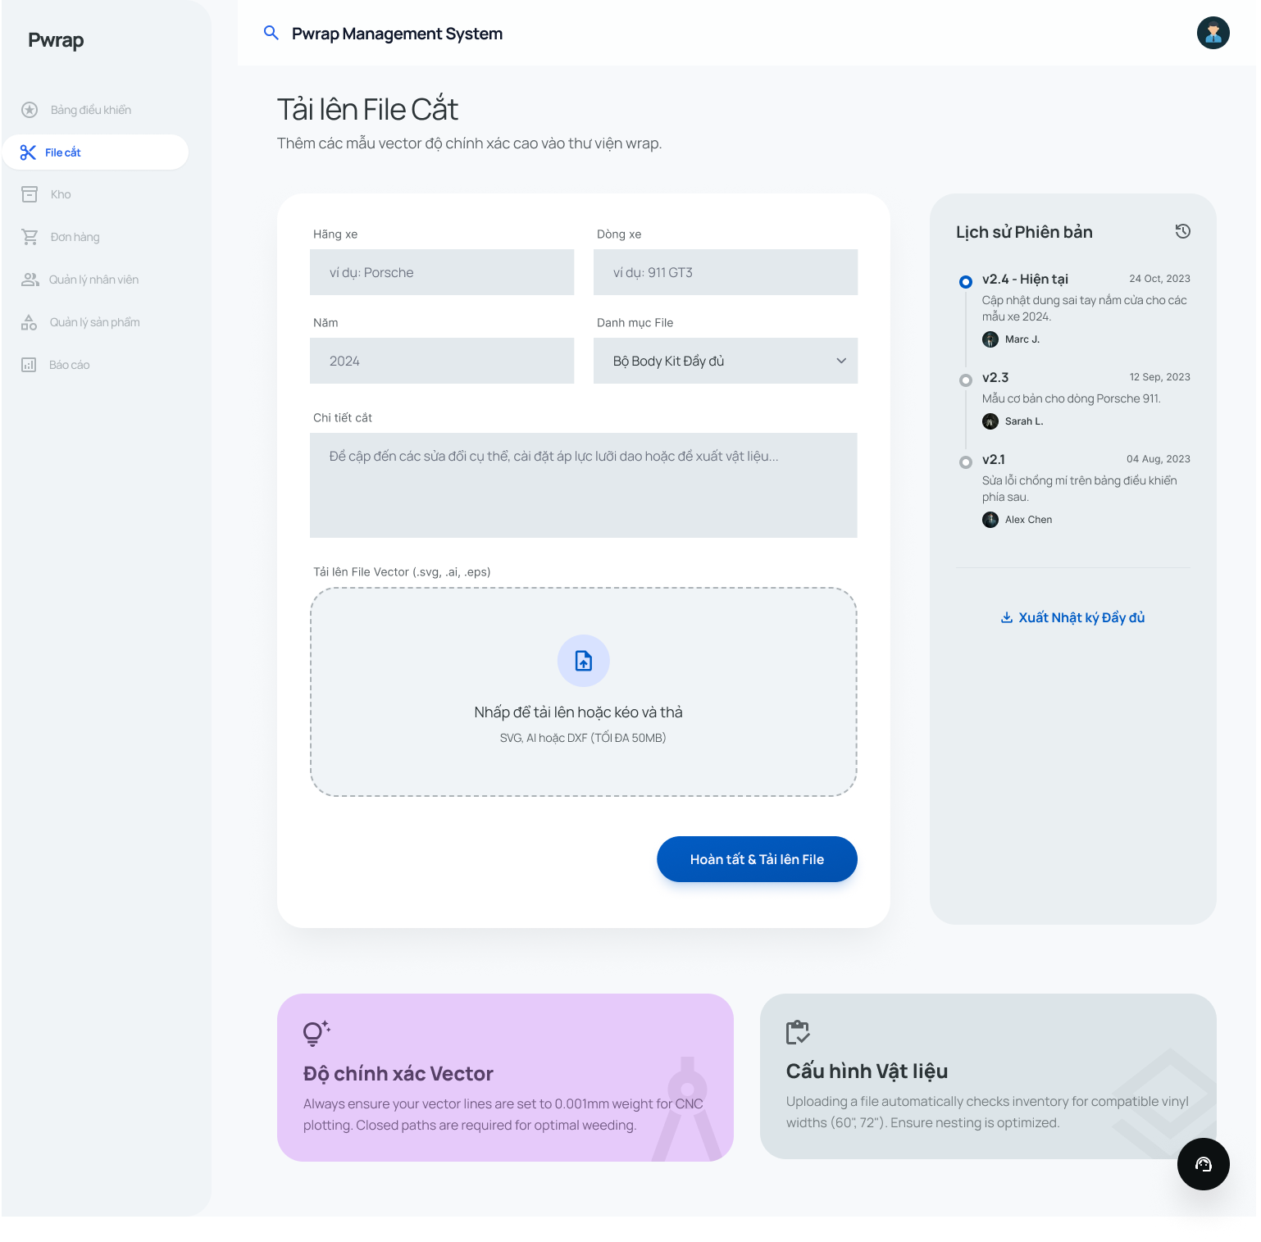

UC11: Preview cut file
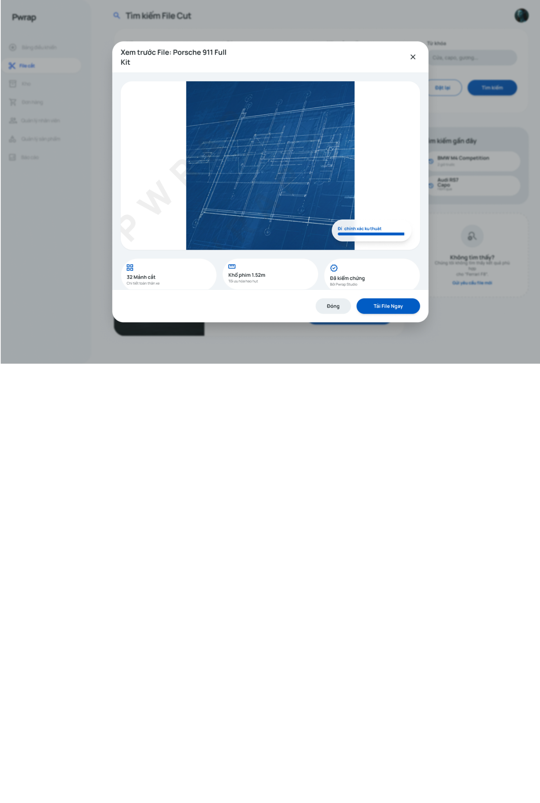

UC12: Track order status

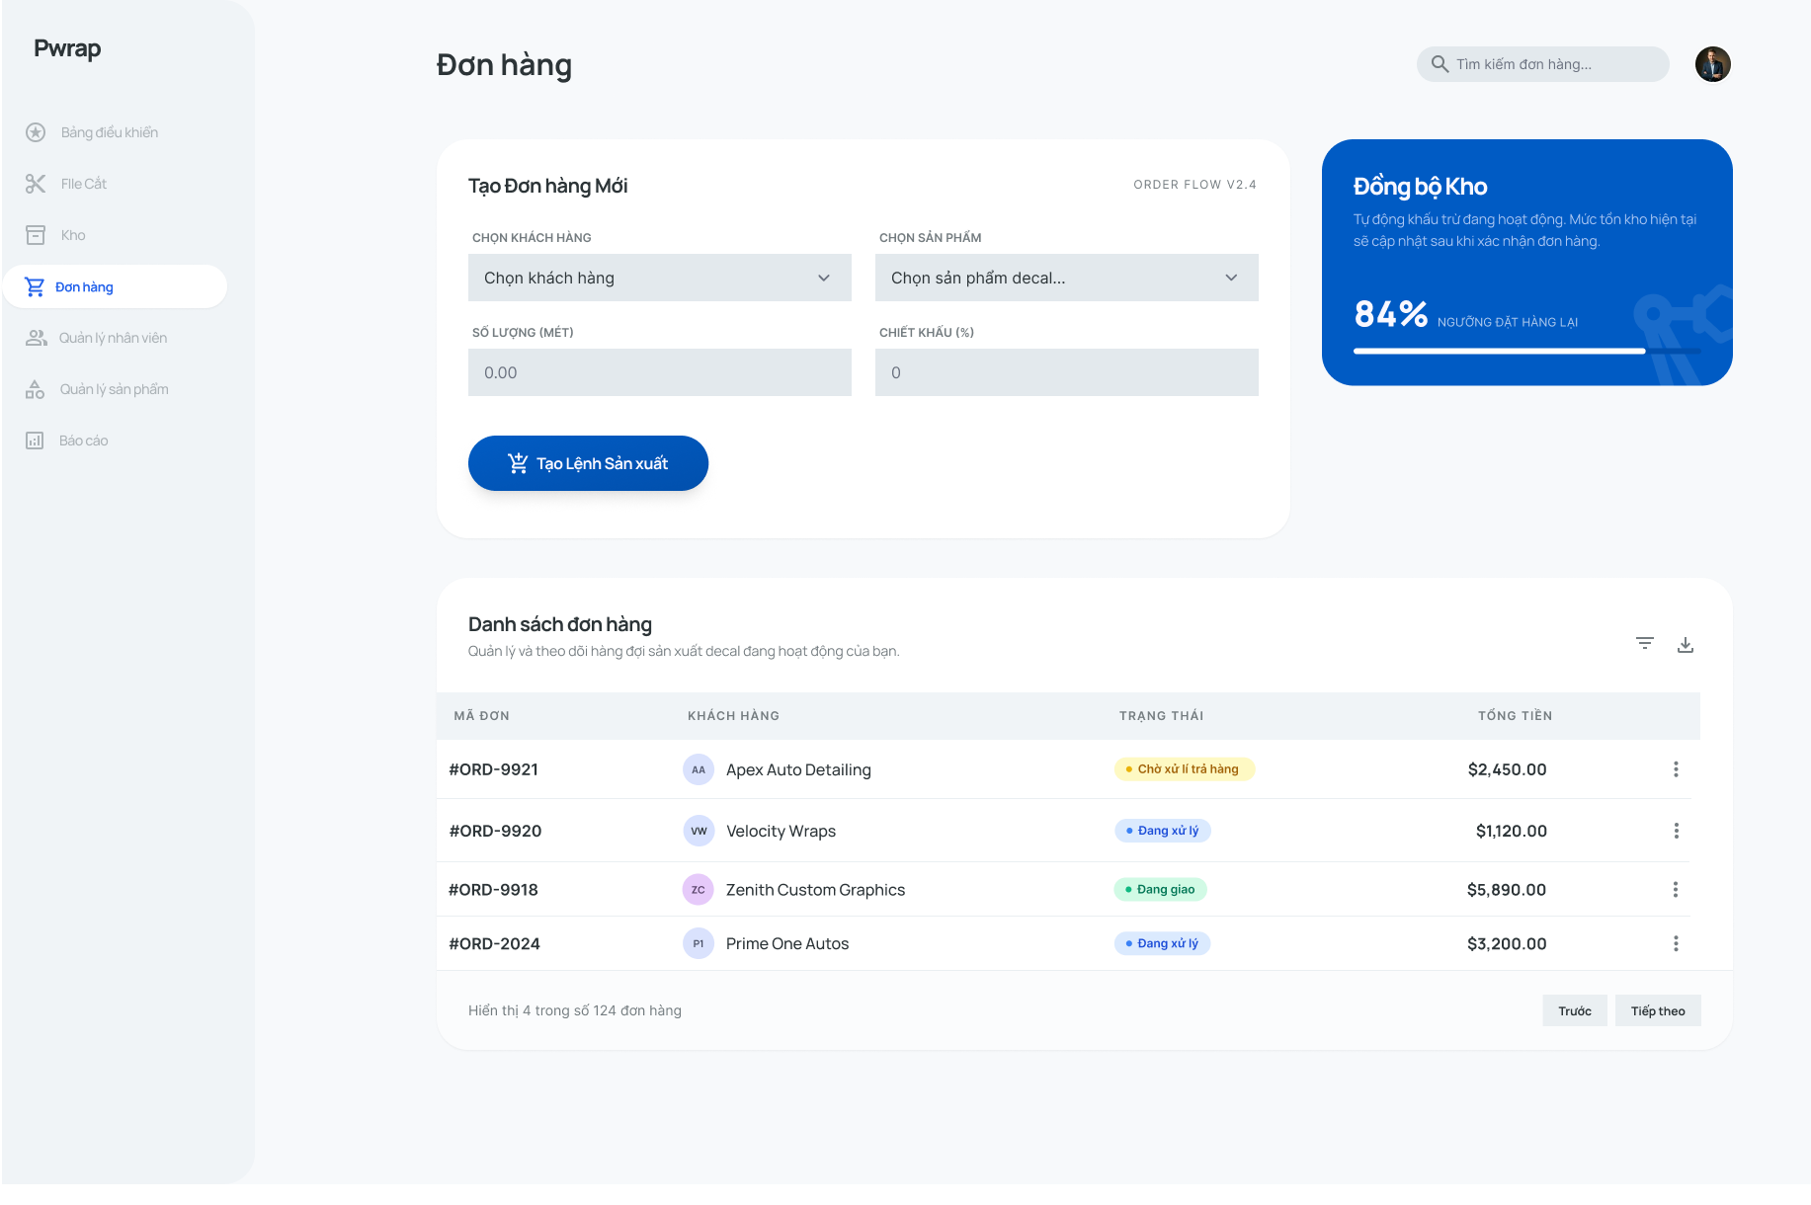
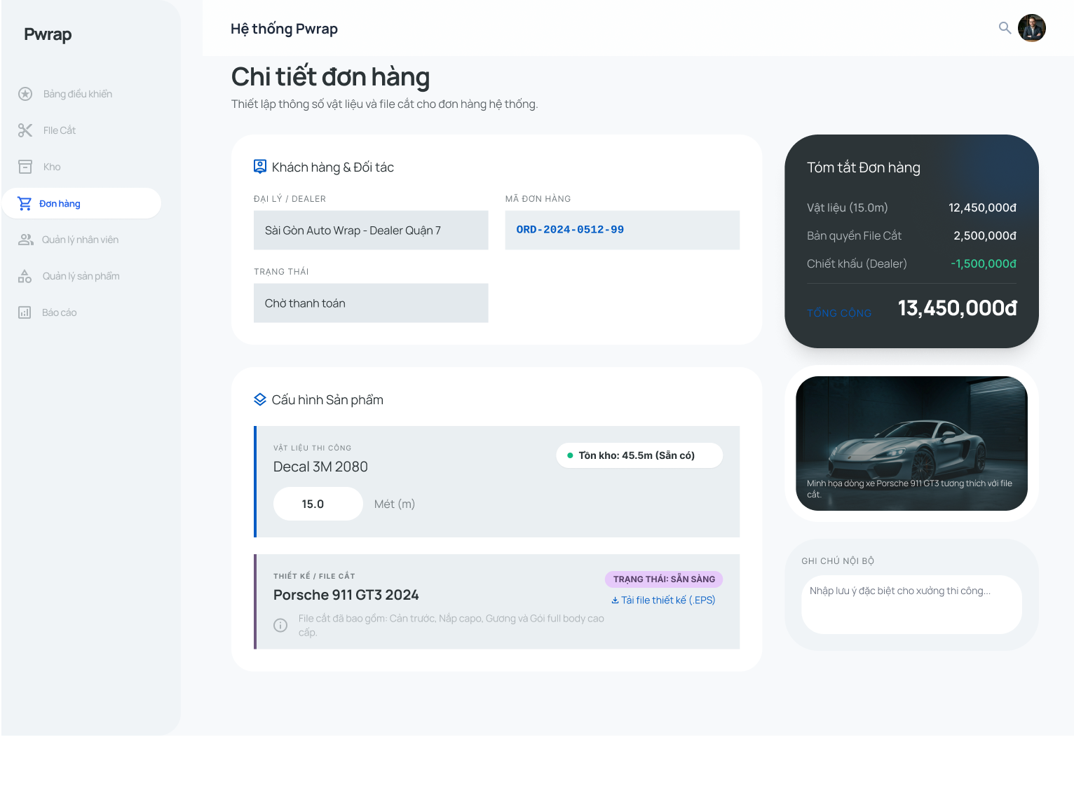
UC13: Process material return
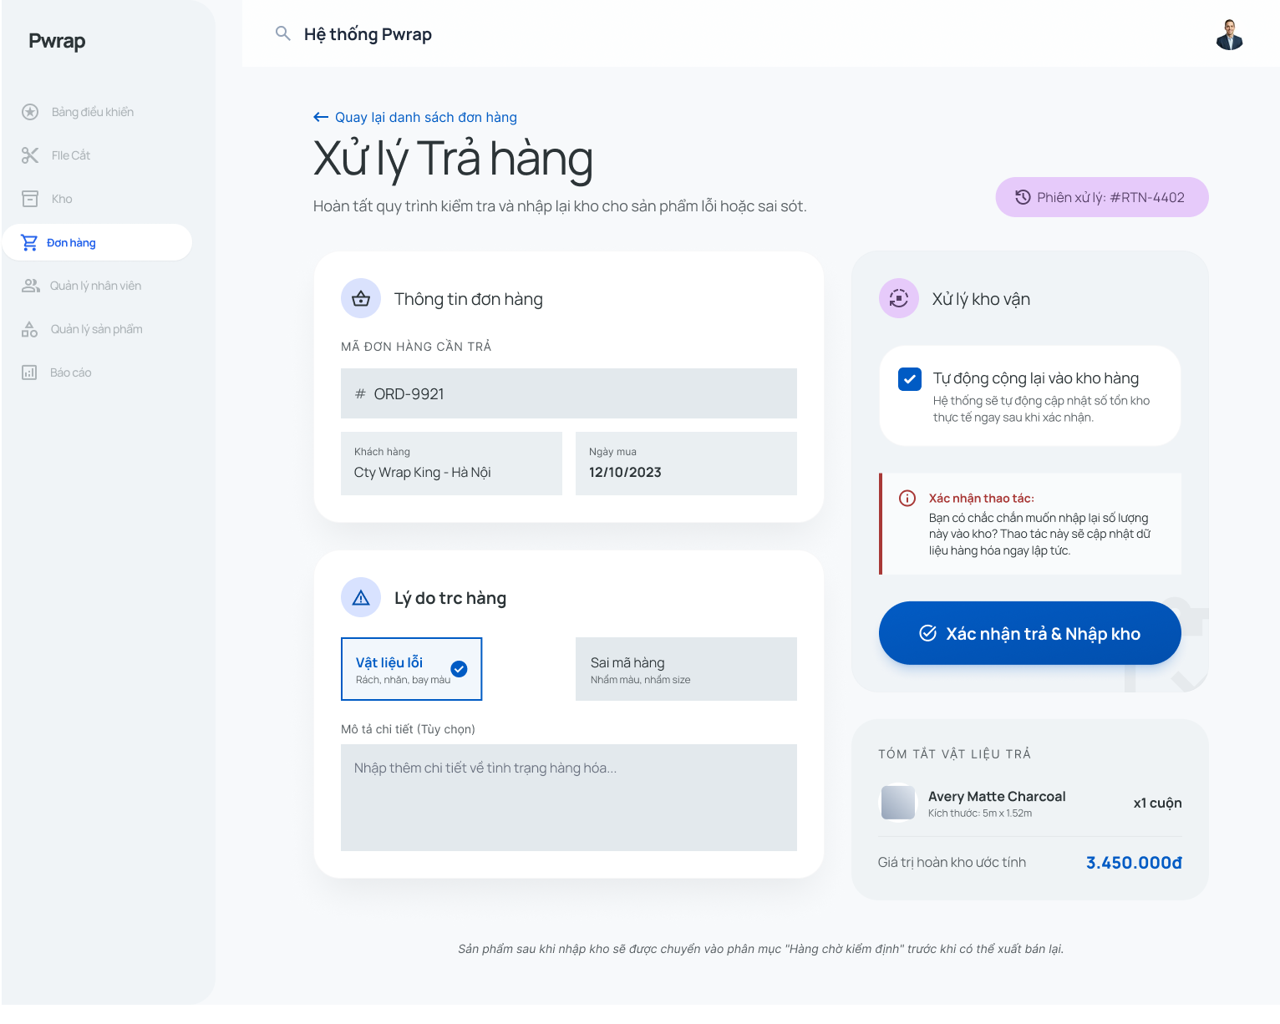
UC14: Generate System Reports
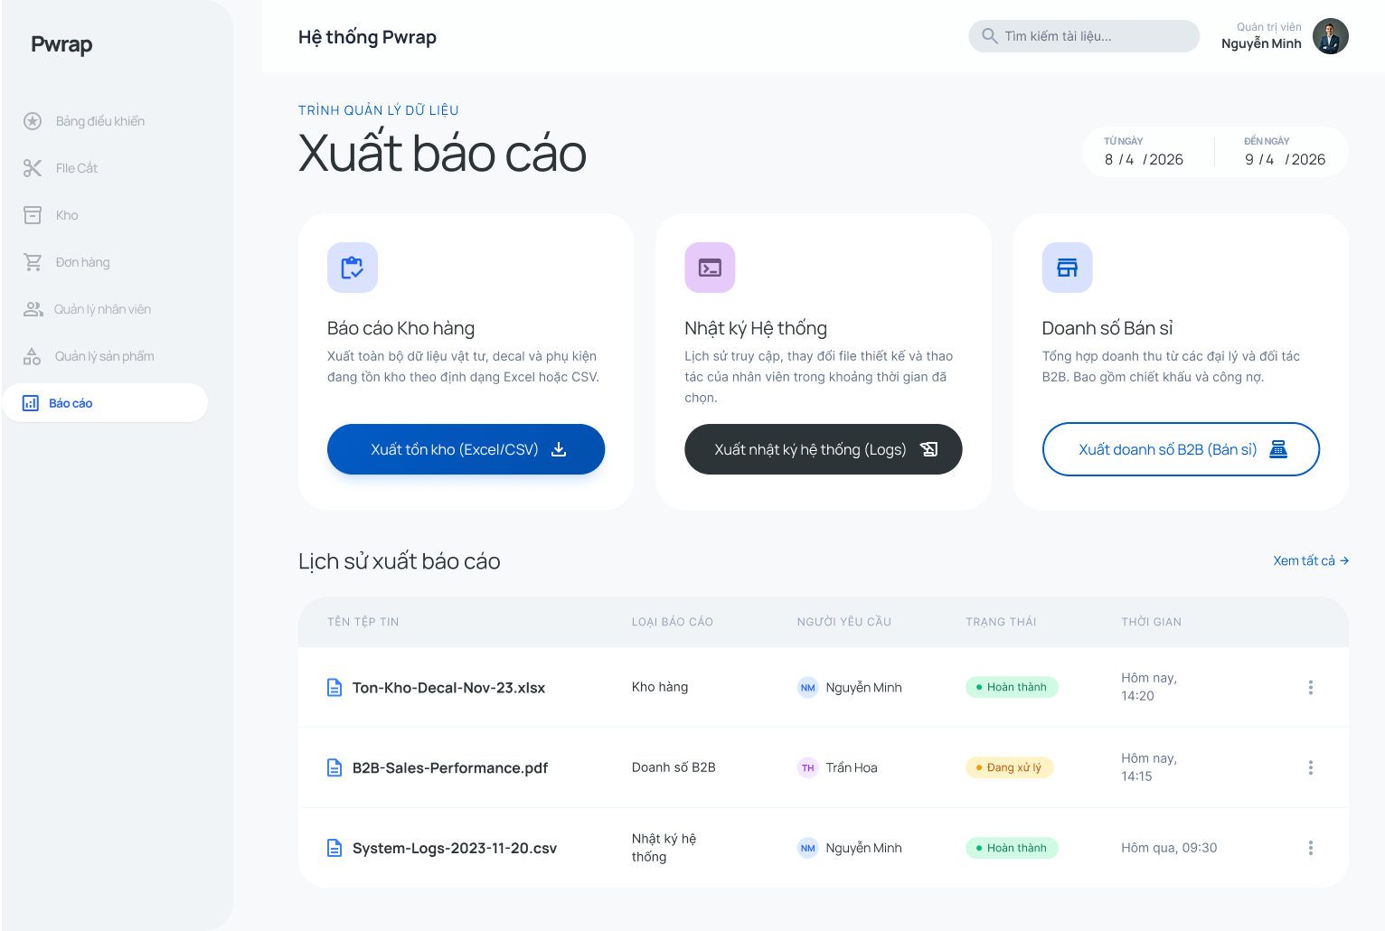
UC15: Add product
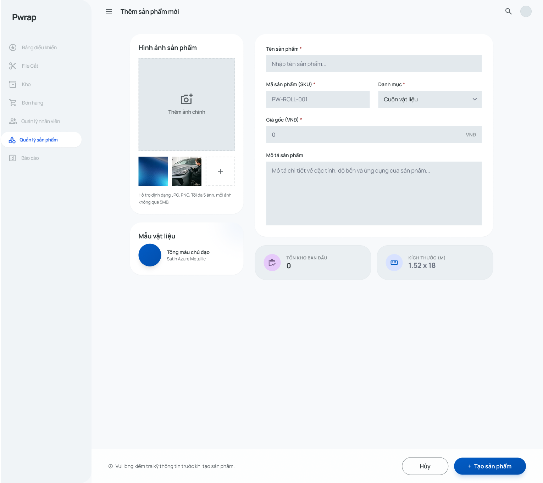
UC16: Update products information
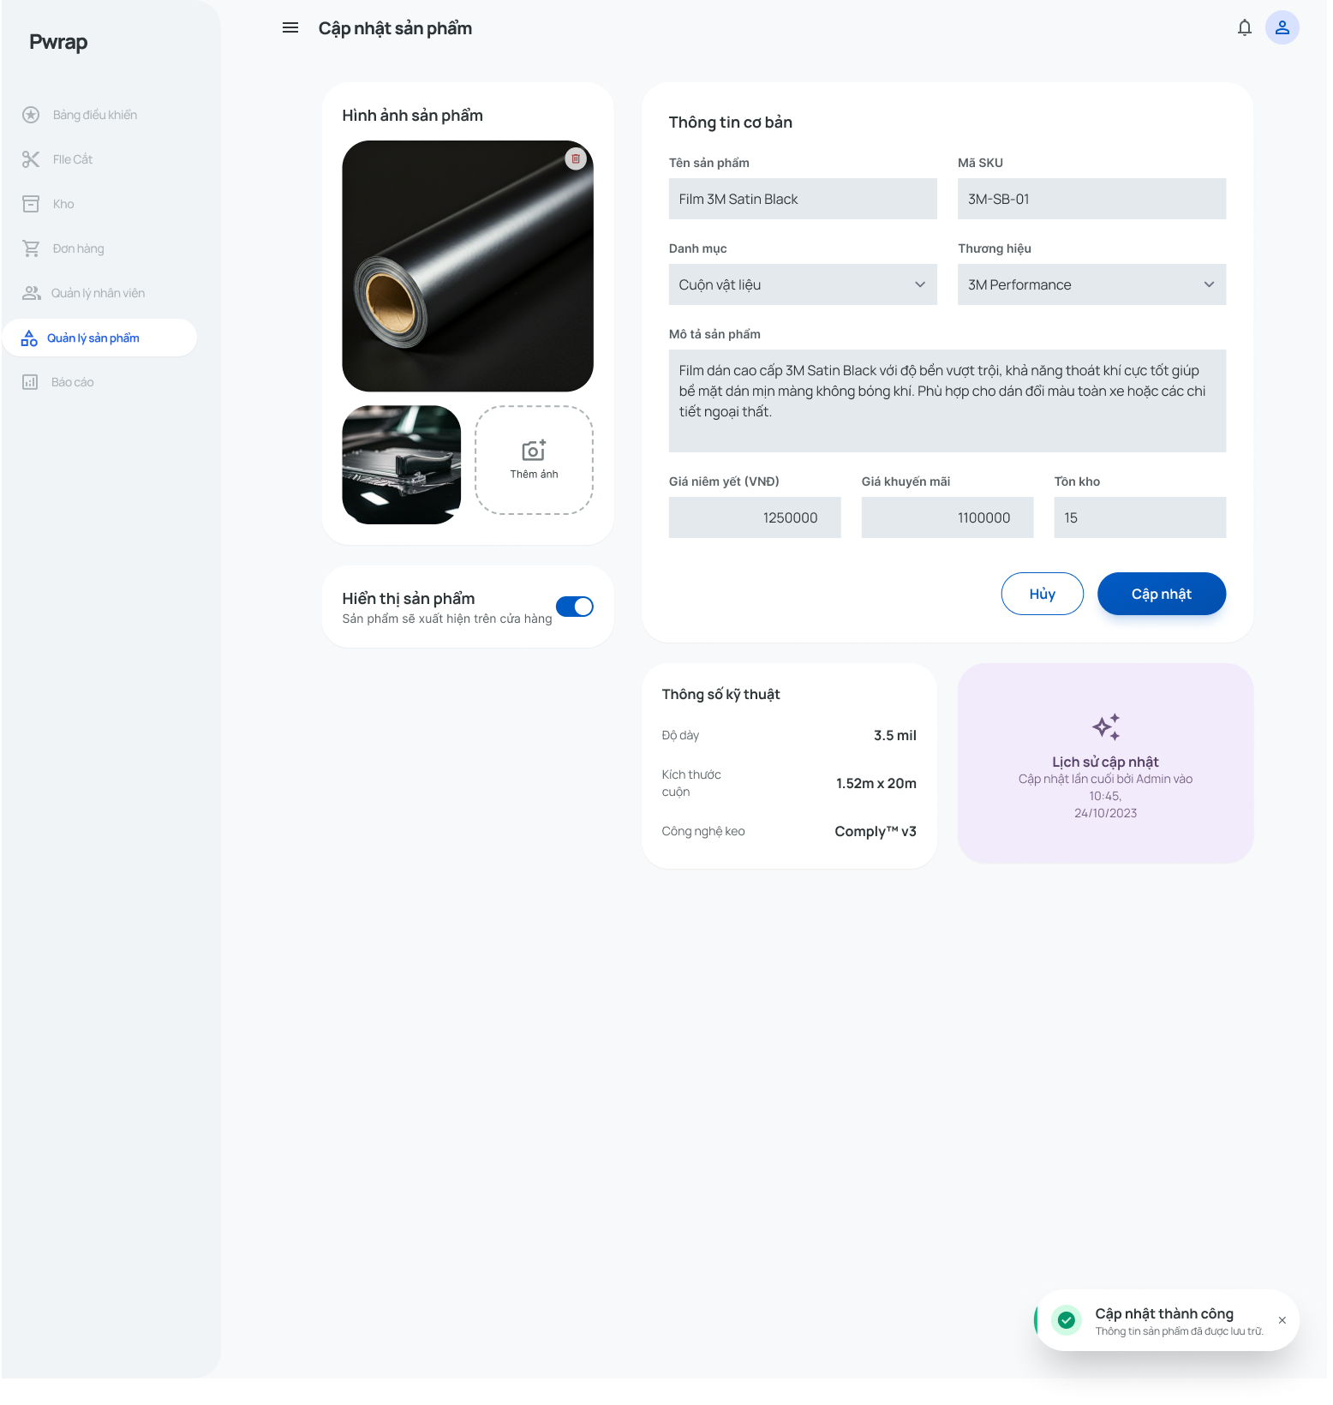
Figure 01 presents the secure login interface, requiring an Email/Username and Password for system access. (Note: Pre-condition requirement for all Use Cases)

Figure 02 illustrates the user management interface, where admins can assign, modify, or revoke system permissions for staff members instead of using fixed roles. (Note: Use case - UC-02: Management Staff Permissions)

Figure 03 displays the system logs interface, allowing the admin to view recent system events, trace concurrent login terminations, and perform security audits. (Note: Use case - UC-01: View System Logs)

Figure 04 depicts the file upload interface for vector files (.cdr, .eps, .dxf) along with required metadata inputs like Car Make, Model, Window Type, and Version. (Note: Use case - UC-04: Upload Cut File)

Figure 05 presents the digital file repository, featuring keyword search and dropdown filters for Car Make, Model, Year, and Material Type. (Note: Use case - UC-05: Search Cut File)

Figure 06 illustrates the material restock interface for logging newly received physical wrap materials, including fields for Material Code, Color, Size, Supplier, and Batch Number. (Note: Use case - UC-06: Restock materials)

Figure 07 displays the dashboard's tabular view showing the current stock levels and status of each material code in the inventory. (Note: Use case - UC-07: View Inventory)

Figure 08 shows the dashboard's automated inventory alerts, highlighting materials that have dropped below a set stock threshold to prevent supply chain disruptions. (Note: Extension of UC-07: View Inventory)

Figure 09 depicts the wholesale order creation interface, allowing staff to select a dealer, add physical materials or cut files, calculate prices, and reserve stock. (Note: Use case - UC-09: Create Order)

Figure 10 presents the cut file versioning interface, allowing admins to upload new file iterations to continuously optimize patterns while securely archiving previous versions. (Note: Use case - UC-03: Update Cut File Version)

Figure 11 displays the file preview interface, showing an automatically generated watermarked image of digital cut files prior to download. (Note: Alternative Flow for UC-05: Search Cut File)

Figure 12 illustrates the real-time tracking module on the dashboard to monitor B2B dealer order progress (Awaiting Payment, Processing, Shipping, Completed). (Note: Use case - UC-12: Track order status)

Figure 13 presents the return processing interface to log reasons for returned/defective materials and automatically update inventory quantities. (Note: Use case - UC-13: Process Material Return)

Figure 14 shows the system data export interface for generating and downloading inventory status, download logs, and B2B sales reports into Excel/CSV formats by date range. (Note: Use case - UC-14: Generate System Reports)

Figure 15 depicts the product addition interface for inputting catalog Master Data details like Product Name, SKU/Product Code, Category, Base Price, and uploading images. (Note: Use case - UC-15: Add product)

Figure 16 presents the product editing interface to modify existing catalog information, adjusting Base Prices, updating descriptions, or toggling product visibility for future orders. (Note: Extends UC-15: Add product / Master Data Management)

